Assignment 5
Relational Algebra

Allocated Excercise 4 & 5 for Roll(7 to 9)

4. Instruct(sID) := π sID σ credit= 4 ^ instructor = "Manoj" (Course offering).

Passers(sID) := π sID σ grade ≥ 50 (Instruct Took).

Answer(surname,FirstName) := π surname,FirstName (Passers Student).
create table instruct11 as SELECT Offering.Oid from Offering, Course where Offering.Dept=Course.Dept and Course.Credit=4 and Offering.instructor="Dr,Manoj";
select * from instruct10

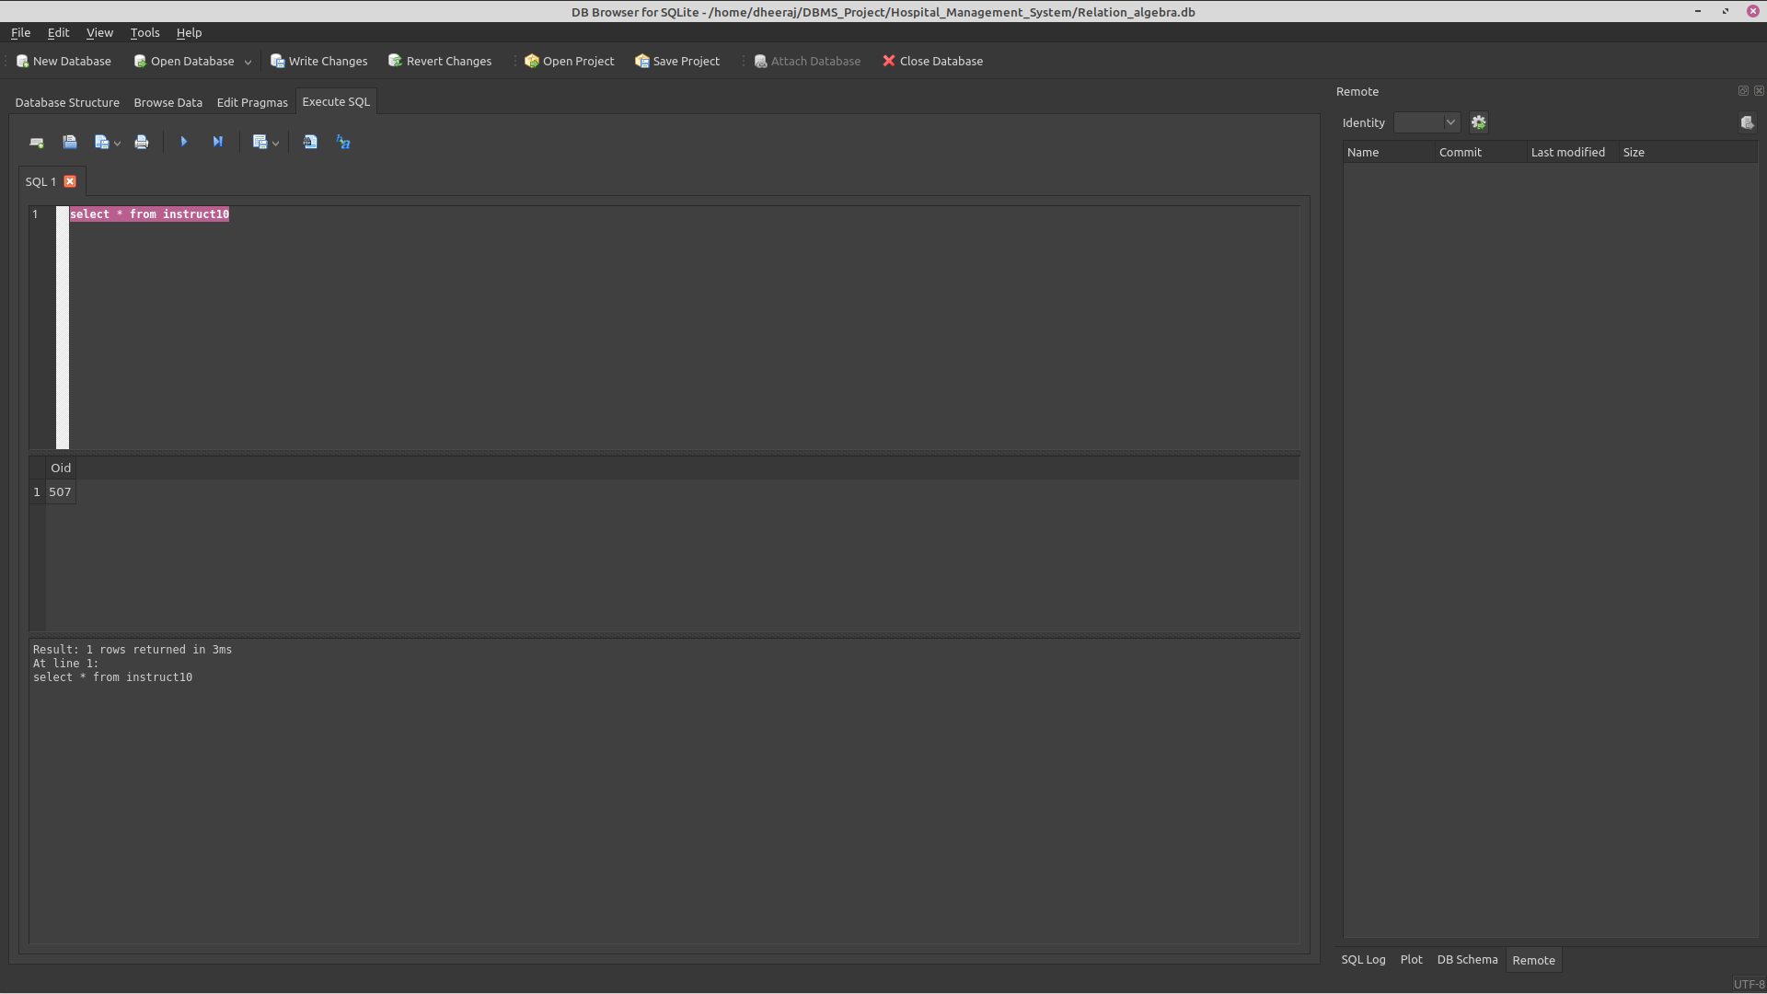

create table passers as select Took.sID from Took, instruct10 where instruct10.Oid=Took.Oid and Took.marks>=50;
select * from passers
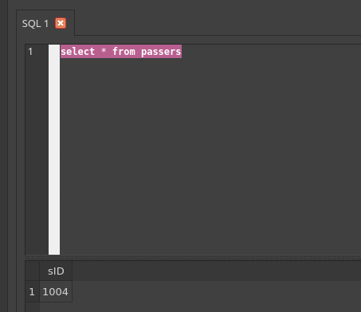

create table answer as select Student.FirstName, Student.surName from passers, Student where passers.sID=Student.sID
select * from answer;
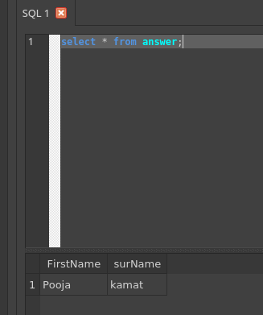

5. (π sID σ grade > 80 Took) ˅ (π sID σ grade < 50 Took)

